**Aim :** To analyze injuries from buses in London

Where do we see the most injuries?

Westminster Borough

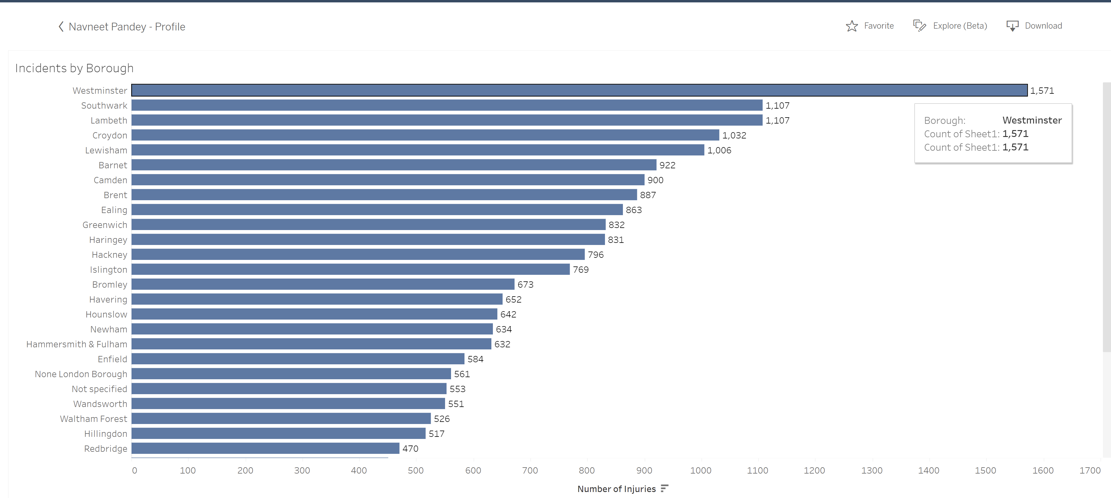

Are some route more prone than others?

Route 24 has highest injuries.

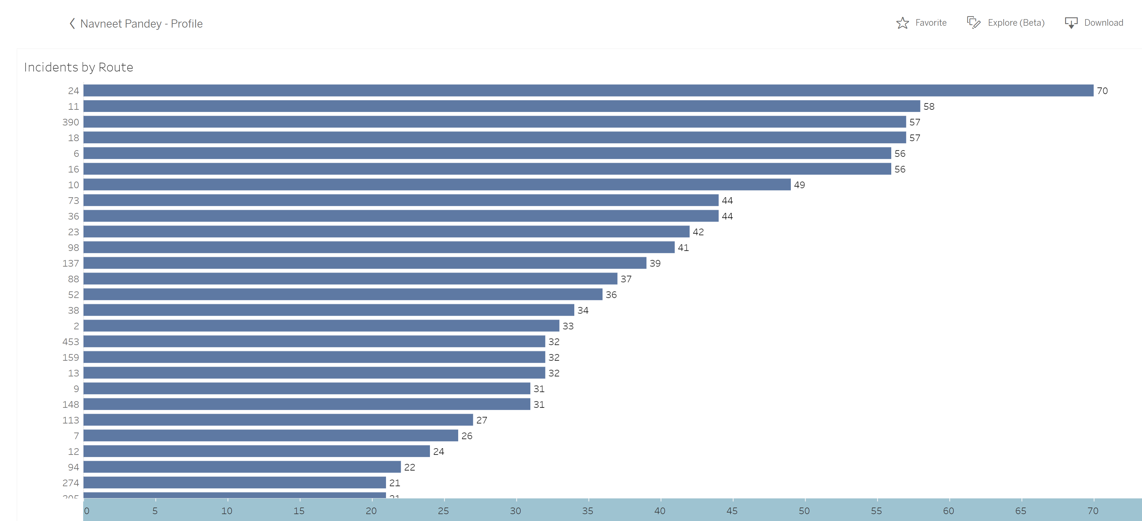

What is the seasonality in which most injury occurred?

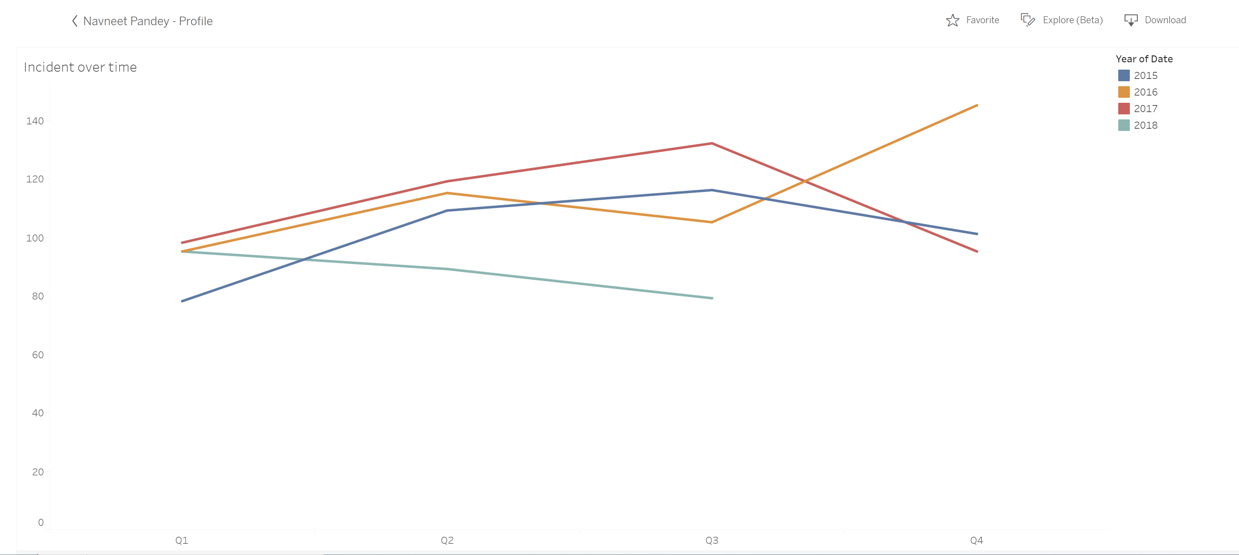

What is the age range of injured people?

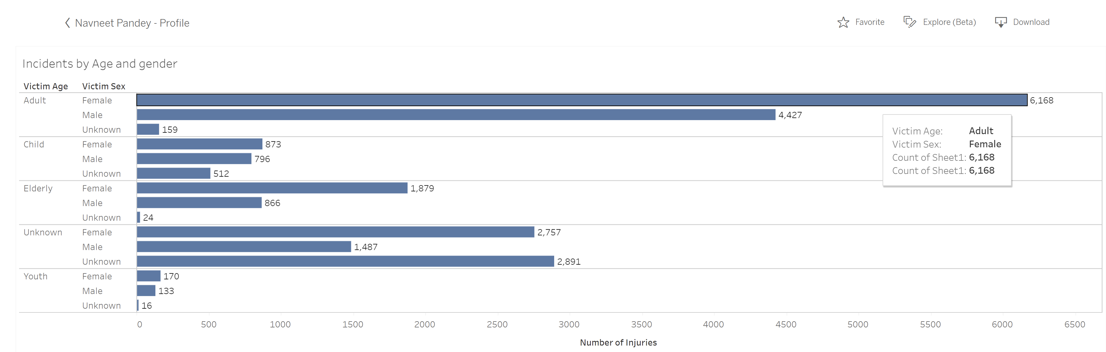

Which year has more injured people?

In 2016

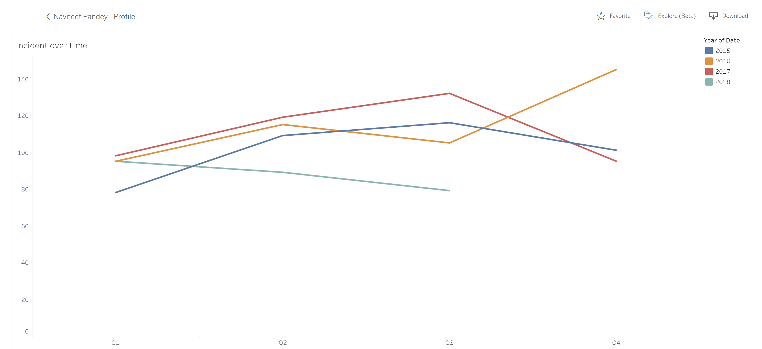

Tableau Dashboard

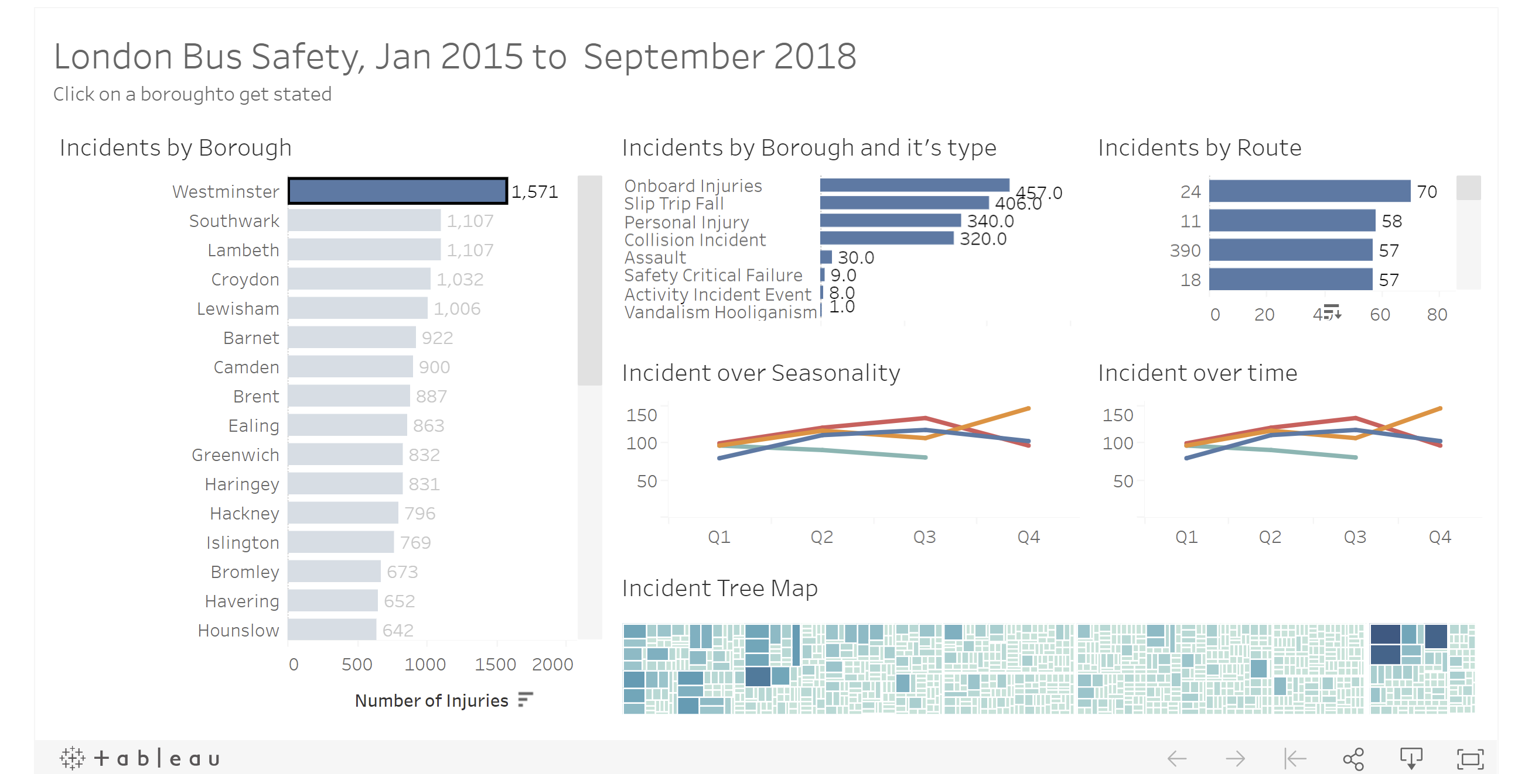

My Tableau Visualization

<https://public.tableau.com/profile/navneet.pandey#!/vizhome/DataVisualizationwithTableau_16050939566100/Dashboard1?publish=yes>